**Module 7: Assignment 3: UI Rendering Integrate Sign-up and Log-In**

Saurabh Verma

Arizona State University

IFT 598: Middleware Programming & Database Security

Professor. Dinesh Sthapit

November 26, 2022

Screenshot of executable server.js file:

Screenshot of app.js file:

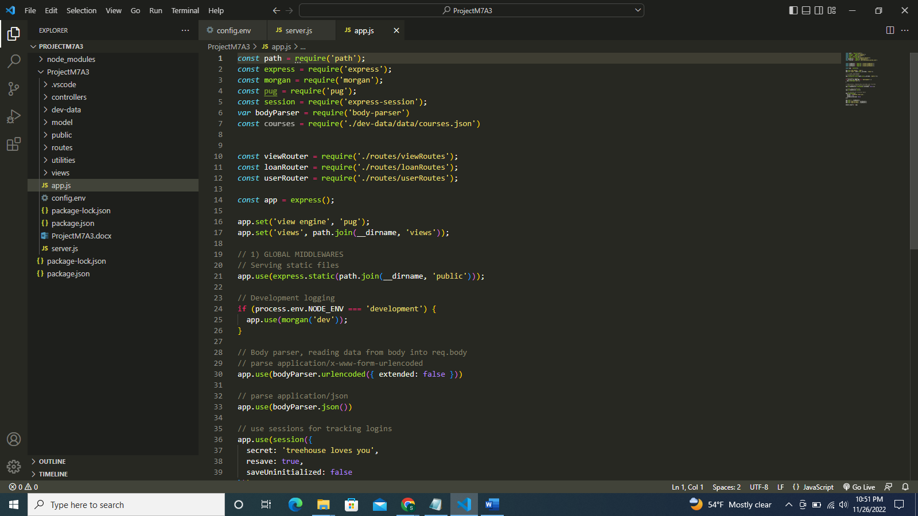

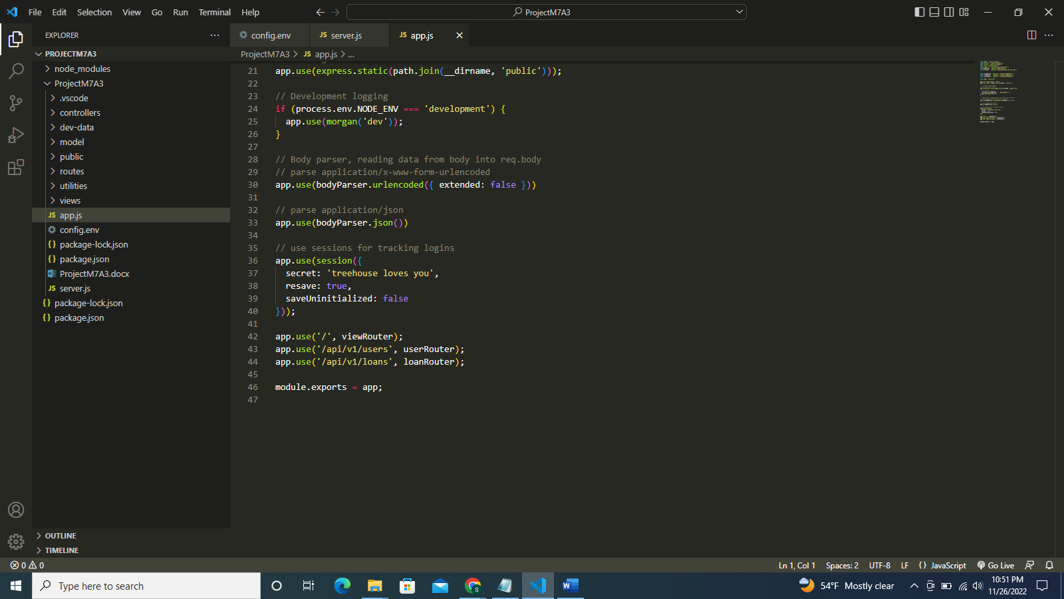

Screenshot of authController.js file:

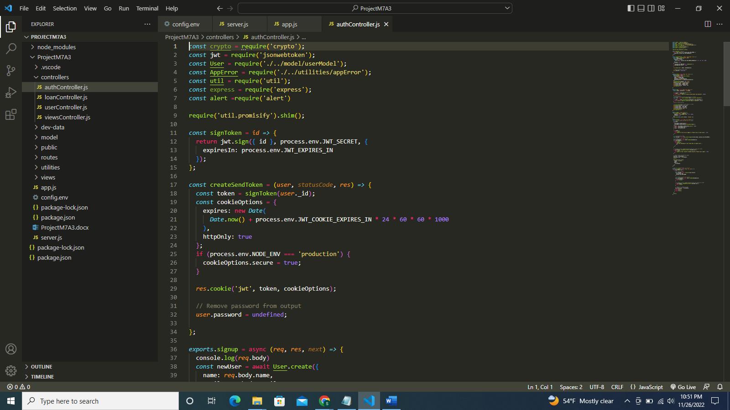

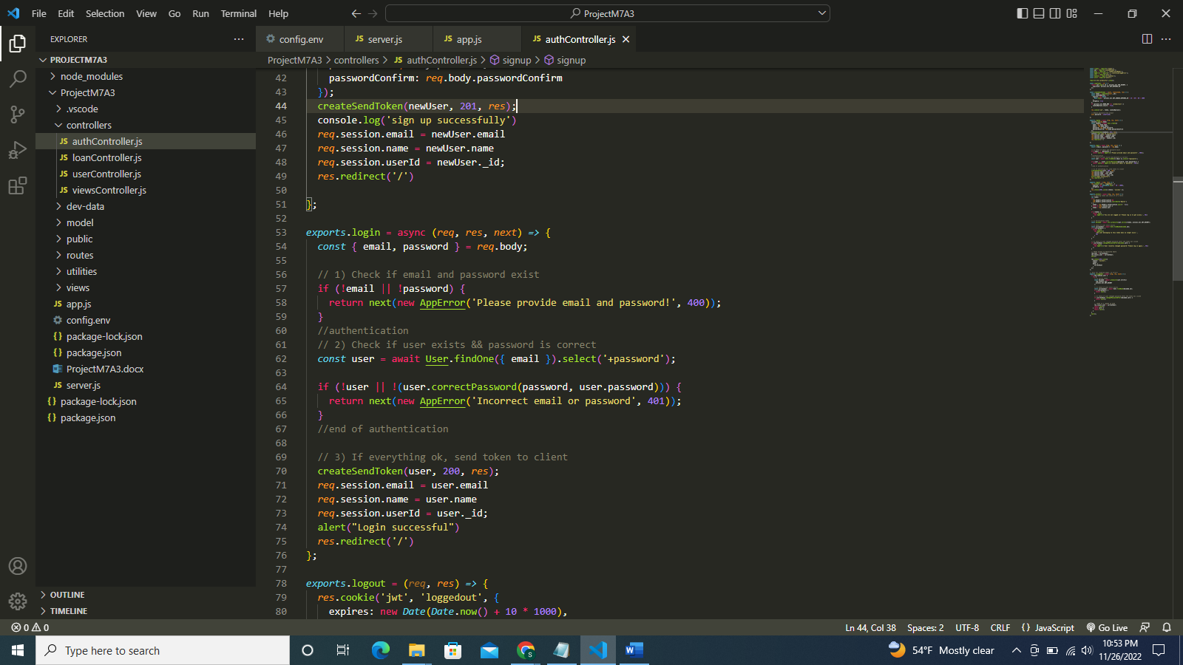

Screenshot of loanController.js file:

Screenshot of userController.js file:

Screenshot of viewController.js file:

Screenshot of login.html file:

Screenshot of newCourse.html file:

Screenshot of newuser.html file:

Screenshot of login.pug file:

Screenshot of newuser.pug file:

Screenshot of newloan.pug file:

Screenshot of alluserlists.pug file:

Screenshot of loanRoutes.js file:

Screenshot of userRoutes.js file:

Screenshot of viewRoutes.js file:

Screenshot of project running successfully:

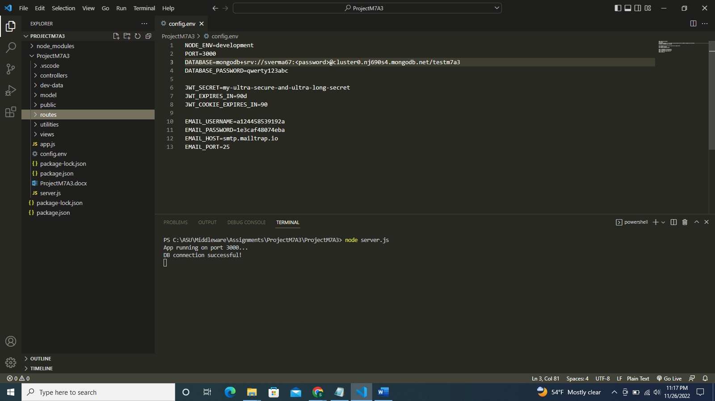

Screenshot of MongoDB:

Screenshot of Overview page:

Now the signup page for new student:

Signing up new student:

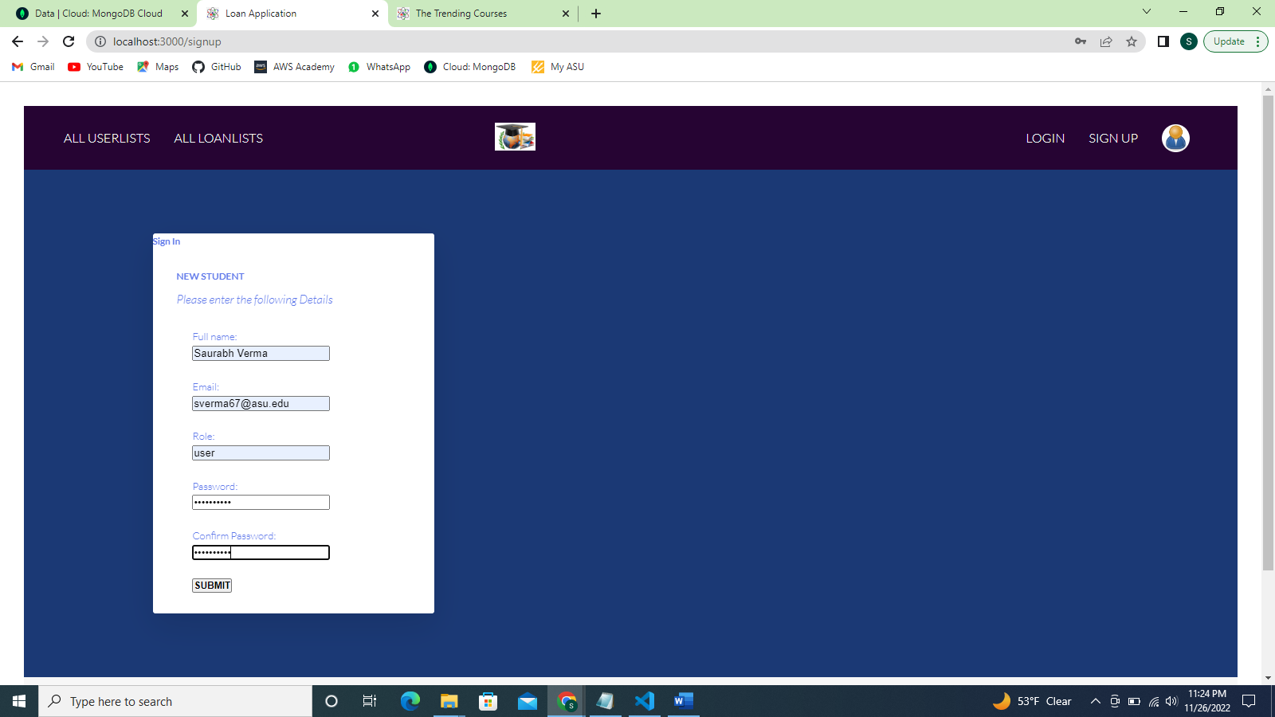

New user signup successful:

Screenshot of record of new user in MongoDB:

Now, login the new student:

New student logged in successfully:

Now creating new loan for new student:

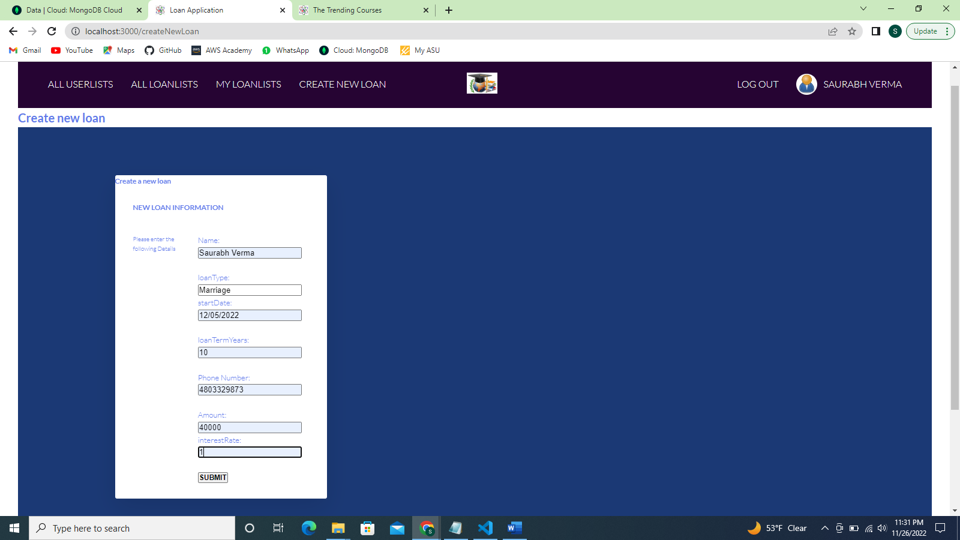

New loan created and displayed in my loan lists page:

Screenshot of new loan created in MongoDB:

Likewise, adding more students:

MongoDB screenshot:

Adding loans for these new users:

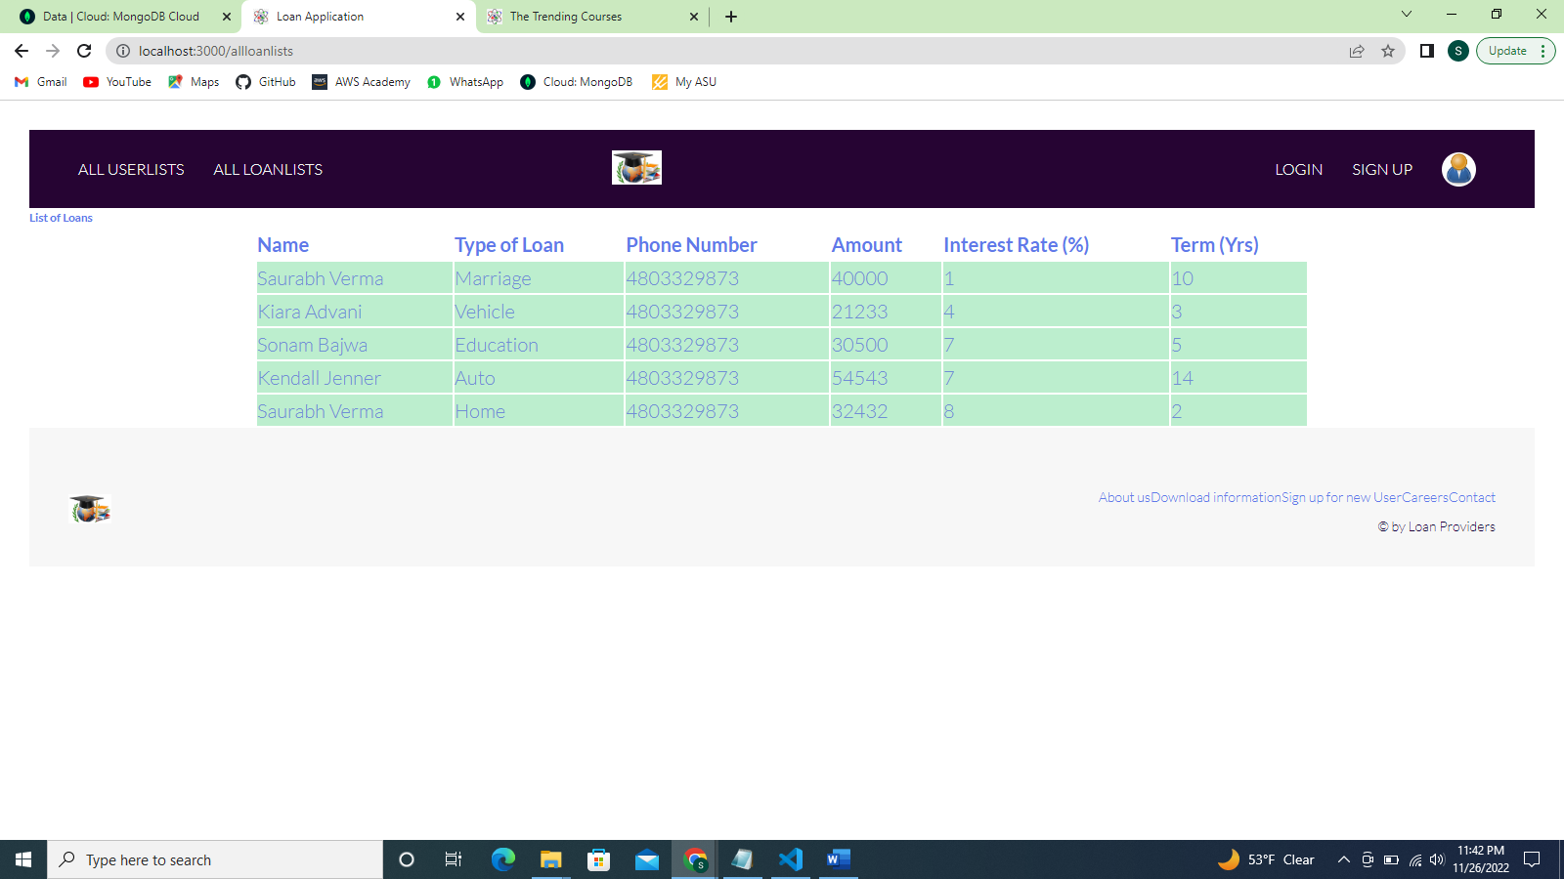

MongoDB screenshot of all loans:

Screenshot of all users:

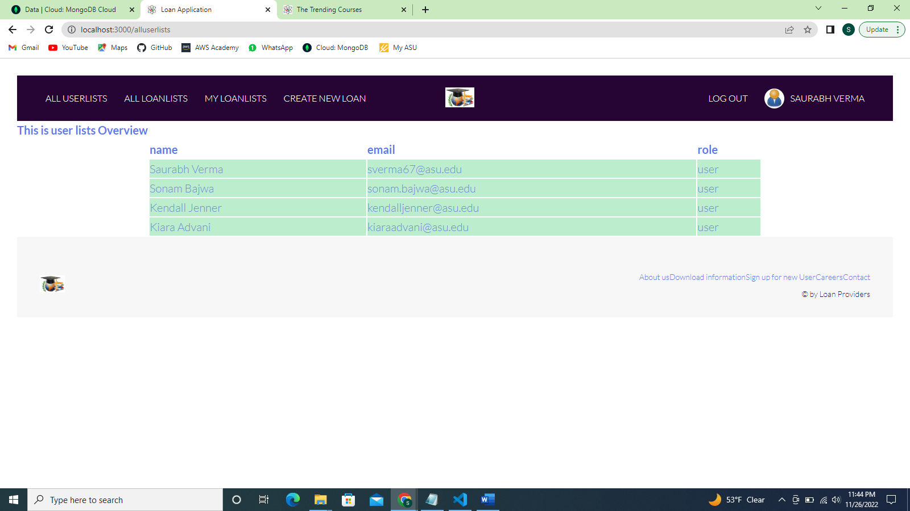

**References**

GitHub link: